PHASE 7 – RESULTS AND DISCUSSION

7.1 Project Results
The developed ServiceNow automation system was successfully implemented to automate the classification and management of IT tickets. The configured flow processes the ticket based on the selected conditions and performs the required actions automatically.
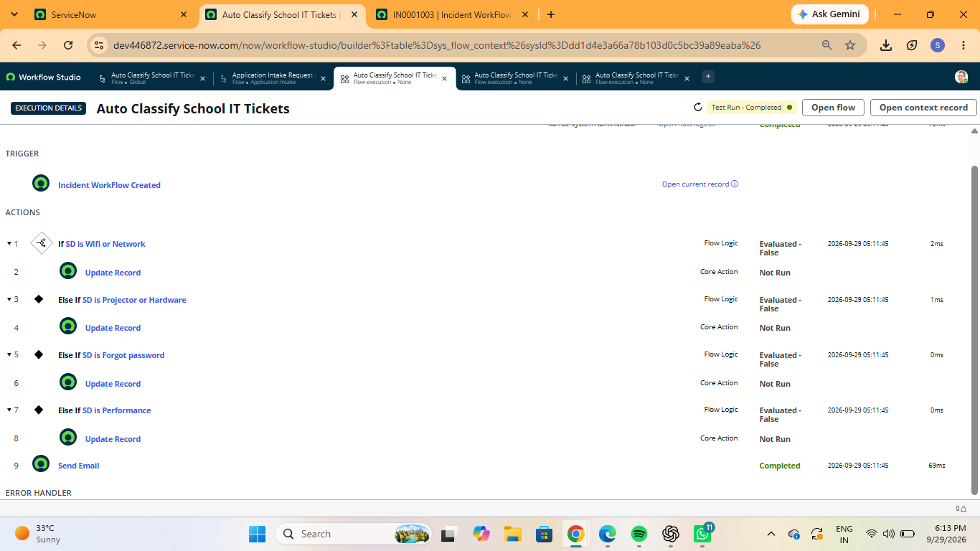
Figure 7.1: Result of the automated ticket management system

7.2 Ticket Classification Result
The automation flow successfully identifies different types of IT tickets based on the configured conditions such as WiFi or Network, Projector or Hardware, Forgot Password, and Performance. This helps in processing tickets according to their requirements.
Figure 7.2: Ticket classification based on configured conditions

7.3 Automation Result
The configured actions are executed automatically when the specified conditions are satisfied. The flow updates the required ticket information and performs the configured actions without requiring manual processing.
Figure 7.3: Automated actions performed by the flow

7.4 Discussion
The project demonstrates how ServiceNow Flow Designer can be used to automate IT ticket management. The automation reduces manual effort, improves the consistency of ticket processing, and helps in handling tickets based on predefined conditions.

7.5 Overall Result
The project was successfully developed and tested in ServiceNow. The testing results show that the configured flow, conditions, and actions work according to the planned workflow. The system provides an automated approach for managing and classifying IT tickets.

